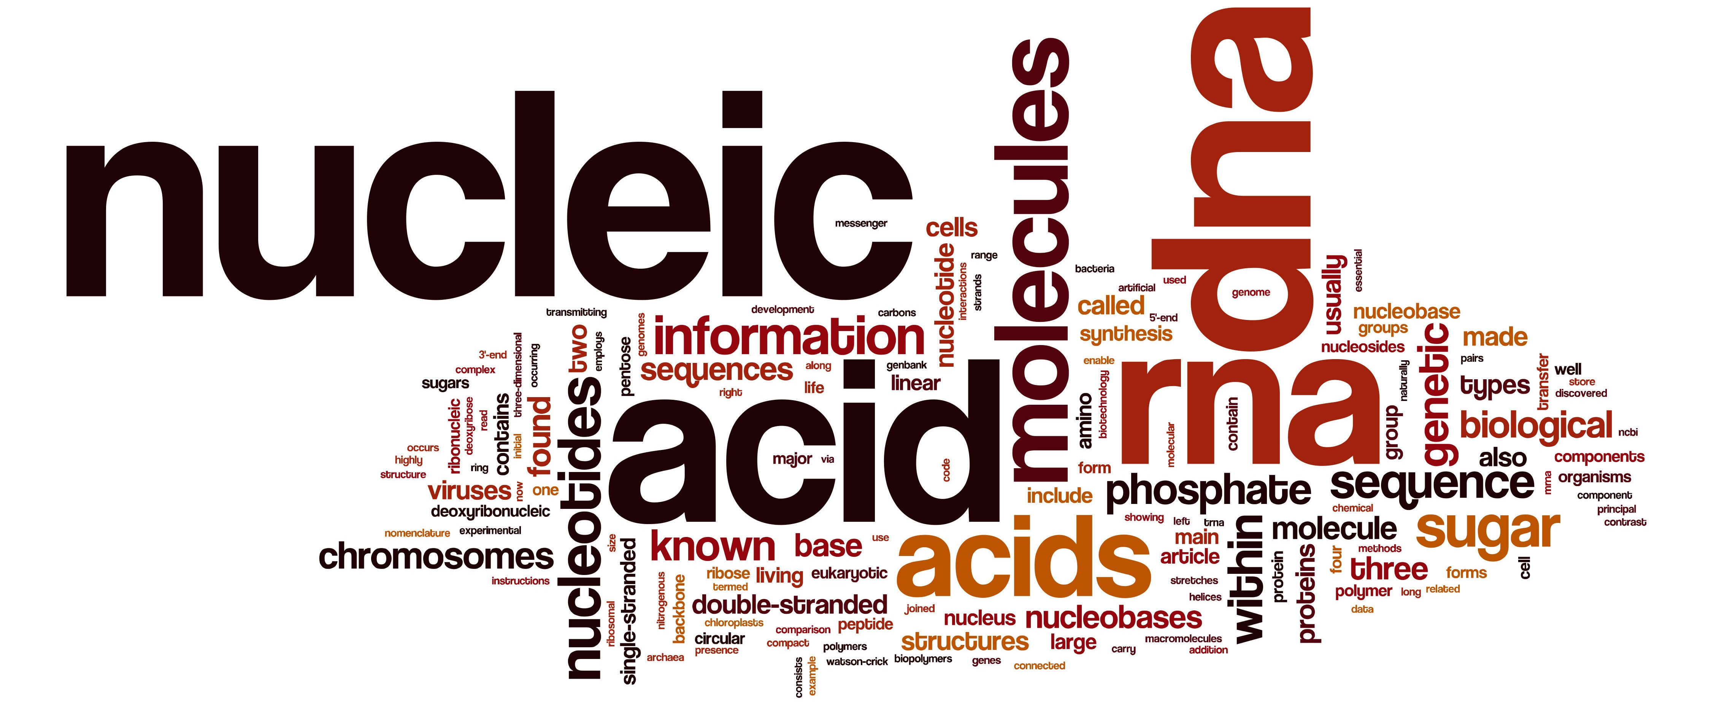

REGISTRATION FORM
In order to register for the workshop please:
- fill in the tables below and indicate if you will submit an abstract and whether you would like to be selected for an oral presentation by marking the selected options with an X;
- save the file as <name_surname_registration.docx>
- send it by e-mail to: erikacione.acidinucleici@gmail.com please put in the object “REGISTRATION”
Name | Surname | Department | Institution | e-mail

 |  | Oral Presentation |  | Academic position
Yes | No | Yes | No | Undergraduate Student | Ph.D. Student | Post-Doc | Senior

Looking forward to seeing you in Rende (CS),
The Organizing Committee

